SOCIAL STUDIES
APRIL 2, 2019
Diane Tober
ROMANCING THE SPERM
Shifting biopolitics and the making of modern families 240pp. Rutgers University Press. $99.95. (Paperback, $29.95)
Rosanna Hertz and Margaret K. Nelson
RANDOM FAMILIES
Genetic strangers, sperm donor siblings, and the creation of new kin
312pp. Oxford University Press. £18.99 (US $27.95).
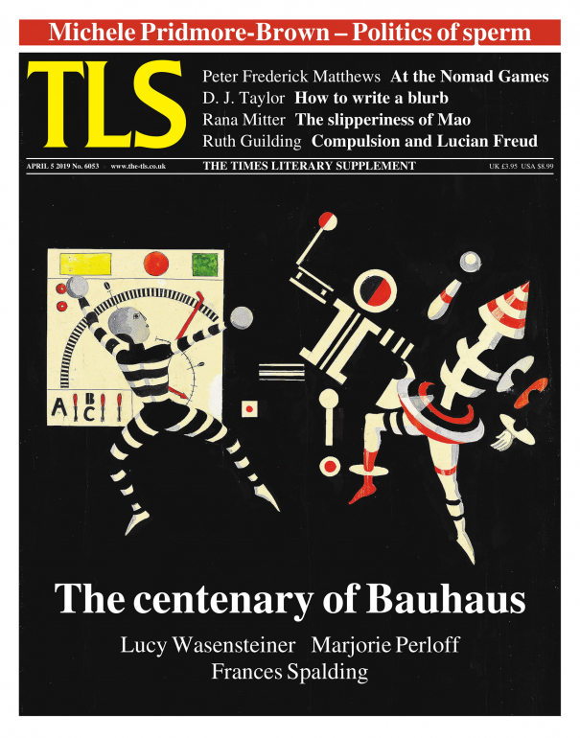
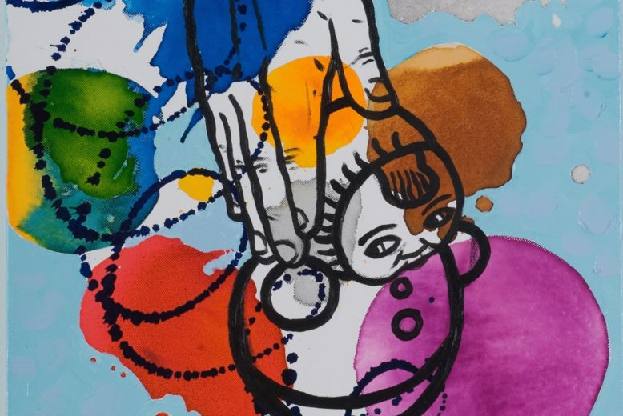
“Staggering touch” by Nóra Soós, 2005
© NoraSoos/Bridgeman Images

Sperm and sensibility

Michele Pridmore-Brown discusses the modern world of designer children, based on age-old preoccupations

MICHELE PRIDMORE-BROWN
Listen to the best journalism: Download the Audm app for your iPhone.
In the insular world of a Jane Austen novel, the rules of the romantic game are well defined. The bit character Charlotte, for instance, in Pride and Prejudice, has a clearly set deadline if she wants to secure her future. She pragmatically “settles” for the tediously pompous vicar Mr Collins, for no other reason than because she is twenty-seven, when the game of choosing is over for women in Austen’s world. Her younger more alluring friends have more time and can ogle better prey – like Mr Bingley. Incontrovertibly a catch, he is kindly, mellow, easily led, well-resourced in the way that counts in this game, and pleasing in appearance. Indeed, his arrival in a mythical town in early nineteenth-century England sets the novel in motion with a flurry of female activity. But his friend the aloof and arrogant Mr Darcy ends up being the real romantic hero, worth far more than Mr Bingley. Elizabeth Bennet falls for him after overcoming pride on his part, and prejudice on hers; or to invoke another Austen title, by merging “sense and sensibility” (economic pragmatism and romantic love or affinity). A fourth male, Mr Wickham, is a decoy: brilliantly feathered in military garb and glib, he is camouflaged as a catch but is in fact insolvent as well as deceitful. Of course, given the requirements of dramatic tension, Elizabeth almost falls for him first.
It’s perhaps no accident that Charles Darwin read Austen’s stylized courtship plots over and again. Her corseted gentrified characters may now seem akin to a weird species of exotically plumed bird, and yet the larger drama of choosing – of who chooses whom, and the timing of that choice – remains a loaded affair, even when it is about swiping left or right, or about choosing sperm from a catalogue.
In Romancing the Sperm, the anthropologist Diane Tober has written a retrospective ethnographic study of the first generation of women openly to buy sperm to make families. The book is about female choice, or, as she puts it, “the biopolitics” of choice when women have resources of their own and the sperm of various male types can be bottled, screened, studied for motility, frozen, catalogued and transported. It focuses on a moment, the 1990s, in San Francisco, and California at large, and then revisits the scene of this first ethnography in 2017 or thereabouts. While Tober’s book is a far cry from Austen’s novels, it centres every bit as much on the drama of choosing – the fantasy and fetish, sense and sensibility, as well as the age-related deadlines – as those novels do. The object of desire here is not a Mr Darcy or Mr Bingley but the child their sperm might produce – hence the notion of “romancing” the sperm. But romancing is now consumption: choosing without being chosen, a transactional act between women and men who would otherwise not make a child together. Inevitably, conservative politicians such as the current US Vice President, Mike Pence, wedded to the old romantic arrangements, detect in these new ones Armageddon.
Unsurprisingly perhaps, California in general was ground zero of reproductive change – or, in another view, the unregulated wild west of innovation. It was there that the first unabashedly obvious postmenopausal births happened, as well as the lesbian baby boom. Older lesbian and single women appropriated practices like sperm (and egg) donation that were initially designed to help infertile heterosexual couples. Tober’s initial wave of in-depth interviews was with forty-two women whom she calls reproductive pioneers, and her book is rich with details about the texture of their lives, the travails of soliciting and ferrying “sperm-to-go”, the democratization of reproductive choice, and about loss. Most of the women are professionals. Some had failed to find Mr or Ms Right in time, their deadline now being around the age of thirty-seven, sometimes forty. She captures their desperation to have a child against the ticking of the clock, and their grim humour, as well as the activism of some that led to legal changes designed to accommodate new kinds of families. But her main insights relate to how women choose sperm. We think of sperm as cheap (at least compared to eggs, which cost $2,000 or more apiece, if that’s the comparison, although no one buys just one egg), but still sperm isn’t free if it comes from a bank and has been screened. At $120 or so a vial in the 1990s, now sometimes $800 or more, costs escalate, especially when women need other fertility services. In a telling extended quote, one older lesbian couple eyeing their declining egg supply as well as bank balance describes how their criteria changed with the passing of months and then years: “we had this whole list of, he had to be smart, attractive, and seem like a nice guy. Now at this point, it’s give me a high sperm count. Give me the most loaded count you can come up with”.
Tober also interviewed the staff of two banks that made against-the-cultural-grain decisions about who was fit to be a donor, or, indeed, a parent. The niche Rainbow Bank, founded and run by an entrepreneurial gay doctor, catered specifically to lesbians and used mostly gay donors when other banks excluded them. It also facilitated “egg meet sperm” parties, which Tober’s descriptions suggest are as freighted with gossip as any Austenian ball or high school prom – except that here it is older women ogling young men for their desirable heritable traits. The woman-run non-profit bank called the Sperm Bank of California served, from its inception in the 1980s, a racially diverse clientele without regard to sexual orientation or marital status. A measure of how much it contributed to, or at least prefigured, changing norms in other places is reflected in the fact that the UK, Finland and Sweden have essentially adopted its protocols. It was the first bank to offer “identity release” donors, who become known when a child turns eighteen – now standard practice, as it is recognized to be in the best interest of the child. And, thanks in part to its actions, in 2016, “parent” and “parent” have replaced “mother” and “father” on birth certificates in California.
At the heart of the book, however, are the dynamics of choice. The ridiculously misguided Genius Sperm Bank – or Repository for Germinal Choice, as it was called – was a decade-long California-based experiment that closed its doors in 1992. Its founder, an octogenarian businessman, had not learned the lessons of the first half of the twentieth century. Thinking to engage in “public service” by enhancing the American gene pool, he drove around the country collecting the sperm of Nobel laureates, or of the closest approximations he could find. He then created “catalogues” of his collection, marketing his vials solely to educated white women with infertile husbands. Around 200 mostly blond babies ensued. Symptomatic of his hubris and myopia was that he fetishized “genius” as the solution to societal ills. It never occurred to him to wonder if the sperm of seventy-year-old Laureates – slow, frayed and likely chock full of mutations – was the best ingredient for creating healthy babies. Or indeed to question the concept of genius itself.
It is against this example that Tober develops her grassroots version of choosing sperm. What remained of the Genius Bank, besides the babies, was the idea of catalogue shopping, but now with the unintended consequence of empowering diverse non-traditional women like those in Tober’s sample. While several women used known donors in the 1990s, catalogue shopping enabled the rest of them to exercise ever more choice, and to think in ever more specific terms about what they wanted in a child. She finds that, invariably, in describing their choices, they used variations of the words “blend”, “fit” and, more loosely, “upgrade”. This last is about securing a child with advantages in a competitive economy – which perhaps can be thought of as the equivalent of securing a man with property in Austen’s world. In the 1990s, as in 2019, upgrade meant choosing the advantage a donor could offer: tallness and smartness, traits the women Tober profiled assumed were at least partly heritable. Even if they didn’t necessarily believe in the primacy of nature over nurture, they were, in the words of one interviewee, pragmatically “stacking the genetic deck”.
A single woman told Tober that her donor should also be “a good blend” with the rest of her family – “yet not have some of my less desirable characteristics like being too fair, or being short and overweight”. She saw donor sperm as a solution to her perceived deficiencies. Other interviewees used words like “relate” or “my type”. They wanted to feel kinship with the donor: a flash of similitude or familiarity, of this being someone they’d like. Tober explains that sperm bank catalogues typically feature profiles of one page each, consumers identify three they like, and then access longer ten-page profiles that can include childhood photos, bits of the donor’s writing, and perhaps recordings of his voice. In reading the profiles, the women envision a child who embodies the traits described, who is their type. Or, as Tober more drily puts it, “they do not wish to have a child who is not their type” – at least not by design. Tober profiles a lesbian couple who cannot picture themselves as parents to a nerdy child, which for them means opting for a donor who was “a doctor, six foot four, played basketball and drank coffee”. A badminton player who didn’t drink coffee was “not their type”. Again, Tober notes similarities with choosing a romantic partner – but in fact the process seems more like choosing the sort of friends one would ideally like to have from among high school cliques: from jocks and athletes, the theatre or music crowd. Opposites don’t attract when fantasizing about a donor as an avenue to a child-to-be. Prejudices stay put. Hobbies matter. An engineer who rock climbs may seem a perfect match. A gun-toting National Rifle Association member may not. One single woman took to a donor who simply drew a line through all the “no” boxes for health conditions, which reminded her of her own impatience with forms.
Tober goes on to describe how women invest sperm with values in more specific ways. Lesbians may prefer a gay donor – investing his genes with “gayness” in what Tober calls a “folk” understanding of genes as encoding certain “values” that mean the child will fit into their communities. Similarly, sperm, like eggs, are imbued with conventional gender stereotypes – tallness matters more in sperm donors, beauty more in egg donors, despite this not making much sense: a girl can look like her donor father after all. As for ethnicity or heritage, consumers look for “ethnic genes” to match their own or their partner’s ancestry, searching for “Filipino genes” in one case, and failing that, Latino or Asian; or refusing Jewish genes because they don’t feel equipped to handle the Holocaust adequately; or only considering Jewish genes because the intended mother’s partner is Jewish – or, more capriciously in the 1990s sample, they like Woody Allen. If the woman is partnered, then, depending on what’s available, they seek to match the heritage, the skin, features, traits and hobbies of the non-genetic parent, which represents a solution of sorts to her or his non- genetic investment, a way of making the child seem like a “blend” of both parents.
But there’s another factor that can’t quite be captured by blend, fit and upgrade: magnetic traits such as cuteness or general likeability, as judged by staff at banks or by consumers using a known donor. Prospective mothers want people to like their child. Of Austen’s four male types in Pride and Prejudice, Mr Darcy divested of his estate seems like the one person no one would choose. A forty-year-old Charlotte can buy his sperm in theory, but would she? With his hauteur, it might be a stretch to imagine his donating sperm, but the fact is that the unreformed Darcy is sure to offend. The staff at sperm banks have a role to play, especially in these early years, in nudging clients towards certain profiles (“he’s so cute, he’d be a perfect fit for you”, they might say). But the dark horse Mr Darcy type is an acquired taste – the staff are more likely to favour the friendly blendable Mr Bingley or the alluring Mr Wickham, as are their clients. A prospective mother is unlikely to create a difficult child by design. Indeed, preferences and choices are inherently tamer, more domesticated, and as Tober acknowledges, more pragmatic, than the oft societally disruptive alchemy involved in choosing, or falling for, or settling for a man, and having his child. Tober calls this process of choosing sperm “traditional” because of the merging of sense and sensibility factors, now articulated as upgrade and fit, but perhaps radically conservative would be more apt.
But what if donors are – like Mr Wickham – pathological liars? Or a little socially awkward like Mr Collins, but with an advanced degree rather than a vicarage? And, on top of this, would a twenty-year-old donor new to adulthood even be able to identify himself as having, say, compulsions, addictions, or road rage? Wickham in theory remains a viable player, and Mr Collins in a vial can seem like a well-endowed stallion in terms of the quality of his sperm, the sine qua non of acceptance as a donor. This isn’t to say that screening protocols aren’t rigorous – fewer than 10 per cent of applicants are accepted as donors in curated collections nowadays.
A medically good donor has obvious characteristics: robust sperm and a clean medical history. A socially good donor, writes Tober, is not only “reliable” in terms of showing up at appointed times with an optimized sperm count, he is “honest” in filling out forms. But there’s still another trait that matters enormously: niceness. In this domesticated context, “nice” men do not finish last. If they signal niceness, they may in fact finish first. Tober and others argue that consumers want donors to express altruistic motivations to erase the commercial aspect of the transaction. They want to create an origin story for their children about “the nice man who helps”. Tober interviewed ten donors and analysed thirty-three donor profiles – and she is firm in her assessment: sperm is a commodity, and yet, because of consumer demand, expressed altruism paradoxically becomes “a secondary commodity”. This means “nice genes” cost more – precisely because they can be turned into a “gift”. The problem here is that, as Tober reminds us, citing Marcel Mauss, no gift is ever driven by pure altruism.
Even if donors aren’t motivated by the money, Tober assures us they feel some sort of “personal satisfaction” in donating – and here, to prove her point, she has only to quote from her interviews: it may appeal to a man to be “a stallion at Mustang Ranch”, as one donor cheerfully told her, reflecting back on his ten-year run as a donor. Another donor who had been pursuing his MA in economics at the time was unabashed in declaring that he was elevating “the gene pool” and said he hoped his children “enjoyed his genes” as much as he did. A third donor, a Stanford student in engineering, donated partly, he told Tober, as a form of rebellion against his strict Catholic upbringing – a “screw you to the Catholic Church” – as well as for altruistic reasons. He was later stunned to realize his sperm had been chosen, yielding several babies. Several donors said they simply didn’t think of the children, whereas others liked the idea of having children “out there”, who, they hoped, might contact them. Tober’s point is not that altruistic motives are inherently suspect, but rather that they are always mixed with other motives.
But all this is Act I and begs the question of what happens in Act II, when fetish and fantasy turn into actual children. Rosanna Hertz and Margaret Nelson’s Random Families overlaps considerably with Tober’s book, and indeed confirms Tober’s findings about preferences, but it also addresses the unexpected social consequences of sperm donation. The title initially seems like a misnomer, since donor-created families are constituted by choice. But, in fact, a new set of “random” affiliations and choices comes into play when families realize they are genetically related to strangers. Families in San Francisco described to Tober passing other families and seeing an uncanny resemblance to their own children. Donor sibling registries and DNA tests now enable parents and their donor-conceived children to systematically locate other families with shared origins, creating what Hertz and Nelson, who are sociologists, call “networks” whose central but usually absent node is the donor. Unlike in the conventional romantic market, mothers using the same man’s sperm are not sexual rivals. On the contrary, they may feel they have inherent commonalities because they made the same choice, or in Tober’s words, romanced the same sperm. According to Hertz and Nelson, when parents see the other children, they may also “express satisfaction” at how smart and talented they are. But this is not always the case.
The authors draw on interviews with 154 donor-conceived children and 212 parents, most of them, as in Tober’s sample, partnered lesbian and single mothers, along with some conventionally married women and infertile husbands. Their sample, however, is far more geographically and socio-economically diverse – an indication of just how much these practices have spread and been normalized in the ensuing decades, even extending into rural evangelical communities that in theory denounce in vitro fertilization. A few families in the book, earning as little as $12,000 a year, shopped in the “clearance section” of sperm banks (which can mean they used a popular donor on one of his low sperm count days, or a less popular donor). As with Tober’s book, there is nothing edgy or particularly speculative here: these are earnest scholars following ethnographic protocols. Theirs is a tidier more controlled book than Tober’s, but the material is, if anything, even more suggestive.
The study confirms that mothers do indeed tell their children about the nice gift-giver. And in Act II, the mothers reference the same variables described by Tober in thinking back to why they had chosen a particular donor – essentially blend, fit and upgrade, with Hertz and Nelson calling the latter “buying the advantage the donor offered”. One sixteen-year-old girl they interviewed was presciently aware of what this meant: “you could pick traits that you wanted in your progeny”. She is aware that her mother gamed the conventional system, and tells the authors: “I’m glad I lived up to that [choice] … Like reading books, and being athletic, and smart and stuff”. In Hertz and Nelson’s words, she feels like a “return on her parent’s investment”. Another girl also cited her intelligence, a trait she knew appealed to her single mother, who, proud of her choice, had repeatedly told her “That’s from your donor. Not from me”. Their mothers are typically open about the donor, and so the children assume traits they don’t share with their mothers or her mother’s relations come from him. The authors note that during periods of adolescent alienation, the figure of the donor can operate in predictable ways – he is likely to be fetishized once again, this time by the teenager. A precocious eighteen-year-old notes that her donor is like Schrödinger’s cat: he exists “in the superposition of all these possibilities”. Inventing him is about inventing oneself.
Still, if most were pleased with their traits, it’s important to note that a few were less so. One seventeen-year-old declared himself disappointed to have “inherited” his donor’s ADHD; others struggled with autism diagnoses. Hertz and Nelson profile five networks of donor-related families, and, in one of them, eight out of nineteen children have autism. One of the mothers says she and her partner had not wanted a “super intelligent” donor and did not realize their donor had “an advanced degree in science”. She had selected him mostly because he was Puerto Rican like her partner at the time, and athletic and musical. If networks have vibes, this one’s was tolerance. Some mothers shared resources about autism among themselves, and two mothers in Chicago from very different neighbourhoods bridged their socio-economic differences to become “soul mates” who talked several times a week.
Hertz and Nelson systematically frame their material in terms of “solutions”. The donor-related networks can be viewed as offering a solution to the winnowing of family trees in past centuries. In the words of one child, having genetic half-siblings is like having “a billion cousins” to choose from. The authors insist on the word “network” rather than “extended family” because the latter implies a certain givenness or involuntariness of connection, whereas, as they put it, “donor siblings become all about choice”. A network is generative by definition. In this context, it’s about shared genes as offering possibilities for meaningful connection, and it’s about agency: about choosing whom to turn into kin and being chosen in turn. Personality matters greatly, of course: some of the children go to gatherings of donor-related siblings reluctantly, some eagerly or insouciantly. The stakes are high. The authors note intriguing gender differences. The boys in their sample, they say, were more likely to fear incurring the obligations of friendship and family, whereas the girls were more likely to be the glue holding networks together, and more likely to fantasize about the donor.
The first network Hertz and Nelson profile results from the early 1990s San Francisco scene described by Tober. A twenty-six-year-old named Justin located his donor, who was delighted to be found, sans children of his own (his is far from always being the case, of course). These two become the centre of the network, creating a “clan” that includes Justin’s lesbian mothers and the donor’s wife as well as an eerily-similar-to-Justin donor brother. The clan gathers for special meals.
The donor’s centrality is atypical, however, especially in newer networks. The authors spend far more time describing the evolution of a denser, younger and probably more representative one. Here, the children met for the first time in 2012, when they were twelve to fifteen years old, a perfect age, as one of them puts it, for a kind of radical openness to the novelty of “building” family. The authors call them “the 7008 Builders”. What they have in common: their mothers chose non-identity- release donor #7008 because they didn’t want a donor to intrude into their lives. The mothers do, however, want to give their children the option of interacting with donor siblings – in case this “somehow” proves to be in their interest. Nine children take part in an original gathering in the centrally located Kansas City, and with a couple of extrovert girls at their centre, they come to profess undying love. The mothers marvel at how safe the children feel around one another; the children marvel at their “freakish” traits in common (same dark hair, same chin; in some cases, an interest in science, like the donor). They fantasize collectively about “him”, creating rituals of belonging – for instance, around listening to a tape of his voice. The authors make this network sound idyllic in a summer camp sort of way, full of exuberant bonhomie. Until it’s not.
Eighteen months later, the children are in their mid-teens or more, and the network has succumbed to the other side of choice: exclusion. New members have joined. Eventually there will be twenty. Some of the original nine report being ghosted. Dyads and triads of like-minded types have formed. An excluded homeschooled girl, Zoe from Tennessee, confirms that the dynamics of “choice” now prevails and she is not chosen. Others confirm that she is not “cool”. She lacks social skills, they say. The authors do a terrific job capturing the intricate play of attraction and repulsion here, and of charisma, privilege and extroversion in determining who is deemed to belong. An exclusive few attend one another’s high school graduations and then post pictures. A trio of artistic and edgy teens bond only with each other.
A latecomer to this network, a nineteen-year-old boy from Arkansas, is a case in point for how these networks can function for identity formation, even when there is no in-person contact. The only child of relatively poor married Mormons (the father was infertile), he finds the donor sibling registry on his own. Only perfunctorily welcomed on the group’s Facebook page, he can nonetheless see in his visibly similar-but-different siblings iterations of who he might be in other circumstances. They are tools for thinking, and reference points for understanding, as the authors put it elsewhere, who he is and isn’t. He hopes to Skype with one donor sibling per month.
With Hertz and Nelson’s final and youngest network, competitive values and benefits are to the fore. The mothers are savvy consumers – they have undoubtedly perused hundreds, perhaps thousands, of profiles. They know what they want, and the children, who are only toddlers, have not yet muddled their agenda. The network consists of fourteen families who all signed up early for the donor sibling registry, not wanting their children to be left out. It’s this network that coined a term for donor siblings, “diblings”, which has since gained traction in the larger community. Describing their donor as exceptionally “nice” and “available” – and the source of the “best genes” they could find, the mothers talk about wanting to affiliate with others who displayed the same discernment in choosing him. While they did want a donor who was available to answer their children’s questions, he is otherwise seen simply as a source of genes. The lateral relationships are the ones viewed as sources of social and cultural capital. They aim to turn diversity – socio-economic, cultural, or geographic, as well as gender or structural differences in family composition – into a feature, not a bug, of this type of reproduction. The geographic benefit is clear: “My child will have a place to stay when she’s in Chicago”. Or in Australia, the Netherlands, or England, where some dibling families are located, the donor’s sperm having traversed several oceans. She can crash on her dibling’s couch. Or maybe get an internship through a dibling parent. At the same time, the privileged professionals take pride in being sensitive to the less resourced. A single mother in rural Ohio is comfortable enough in the network to declare that having diverse diblings enables her son to see how other people live in the manner of city versus country mouse. He might visit a dibling in New York.
A mother remarks that all who chose the donor are “similarly kind and open-hearted people. It’s just really … interesting how similar we are … How cool is that”. This is the sensibility part – the desire to affiliate with and create children who display curiosity and openness. At the same time, one mother emphasized the “sense” part: “I hope my daughter will say these connections deepen her Rolodex”. The mothers believe they are securing useful advantages for their children in a competitive world by way of another layer of community – and, the authors somewhat coyly add, perhaps with a hint of authorial scepticism, by way of “another set of Facebook ‘likes’”. At some point, the children will choose among diblings, un-liking some, just as the mothers chose among sperm donors.
Families are of course inherently precarious institutions, however constituted. The dibling phenomenon is an unexpected if messy benefit of Act I. It is about another layer of choosing, and about the existential drive for connection, now brokered through “genes”. “Network benefits”, a product of a recently emerged cultural mindset, were certainly not thought of by those donor-enabled families who uneasily passed each other in the streets of San Francisco in the 1990s and worried about incest. The mothers in this last network believe from the outset that their children will have competitive advantages compared to children born in conventional families.
Both books raise the question of what’s next on the reproductive frontier. Tober returned to San Francisco in 2017. The Rainbow Bank had gone out of business, its clientele absorbed by the California Sperm Bank, which remains a non-profit organization committed to diversity. Egg-meet-sperm parties are still in full swing, now including surrogates. But a new population, transsexuals, are pushing reproductive boundaries in so-called grassroots or niche directions, much as lesbians and older single women did in the 1990s – romancing “trans sperm”, for instance, which they believe will best fit into their families; or medically managing their own bodies for reproductive purposes – by, for instance, freezing eggs before transitioning, or using a leftover womb as an otherwise transitioned man. The Sperm Bank of California is, as a result, changing its language from “single moms” and “lesbian couples” to “recipients” and “partners”. Plenty of research shows that children can thrive in all sorts of families so long as they have committed adults in their lives, research the American Society of Reproductive Medicine cites in its ethics documents. New technologies will doubtless continue coming up the pipeline, offering ever more choices. But, if these two books are any indication, what will never change is the age-old human drama of pride and prejudice, sense and sensibility, fantasy and fetish, courtship and exclusion. And the desire to create children with advantages in a competitive world.

